**Snapshots of Stock Data from Multiple Years**

**Snapshot of Stock Data from Year 2014**

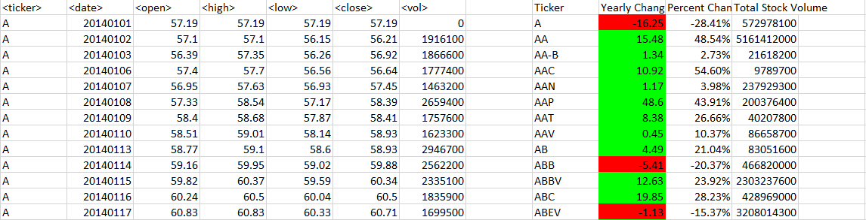

**Snapshot of Stock Data from Year 2015**

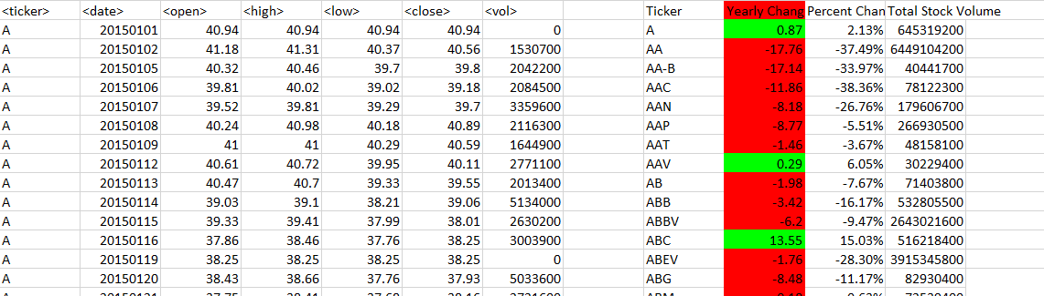

**Snapshot of Stock Data from Year 2016**

